Quantifying shoreline modifications adjacent to eelgrass meadows in the Strait of Georgia Bioregion

Here is the abstract text. Lorem ipsum dolor sit amet, consectetur adipisicing elit, sed do eiusmod tempor incididunt ut labore et dolore magna aliqua. Ut enim ad minim veniam, quis nostrud exercitation ullamco laboris nisi ut aliquip ex ea commodo consequat. Duis aute irure dolor in reprehenderit in voluptate velit esse cillum dolore eu fugiat nulla pariatur. Excepteur sint occaecat cupidatat non proident, sunt in culpa qui officia deserunt mollit anim id est laborum.

# 1 Introduction

The health and functioning of coastal marine ecosystems are under threat from a variety of human activities (Halpern et al. 2019). Coastal activities such as agriculture, residential development, forestry, and shoreline hardening create pressures on the marine environment. A modified shoreline may alter levels of sedimentation, nutrient runoff, pollution, and wave energy in the nearshore environment (Dethier et al. 2016; Todd et al. 2019). For coastal biogenic habitat in British Columbia such as seagrass, these pressures can impact seagrass productivity and survival, and thus impact the community of species that rely on seagrass (Iacarella et al. 2018; Nahirnick et al. 2019; Murphy et al. 2021). Therefore, knowing the presence of shoreline modifications adjacent to seagrass meadows would allow us to predict ecological impacts and understand seagrass ecosystem dynamics in a broader seascape context.

Assessing human activities for an entire coastal region is generally done at broad spatial scales. For example, impact mapping and assessments for all of BC have been done with a 2 km+ spatial resolution (Clarke Murray et al. 2015), which exceeds the size of many seagrass meadows as well as the size of the shoreline region which could be locally impacting a meadow. In addition, many spatially distinct meadows may exist close together, where only a high resolution assessment of shoreline modifications could distinguish the potential impacts between them. Fine-scale assessments of impacts to seagrass exist for the BC coast, but these are typically done in detail for only a few meadows due to logistical constraints (Iacarella et al. 2018; Nagel et al. 2020).

The objective of this study is to map and quantify the shoreline modifications adjacent to all known seagrass meadows in the Strait of Georgia Bioregion of British Columbia. Eelgrass (*Zostera marina*, the dominant habitat-forming seagrass species) is a conservation priority in British Columbia (DFO 2019), and eelgrass meadows have been designated as Ecologically and Biologically Significant Areas (EBSA) due to their productivity, sensitivity, and support for biological diversity (Rubidge et al. 2020). Therefore, it is important to acquire information on human activities to predict impacts and categorize meadows by their degree of naturalness, as areas of high naturalness may be a priority for additional management and conservation efforts (UN CBD 2008). While shoreline modifications do not represent all of the human activities potentially threatening seagrass, a high resolution dataset is currently needed and can complement other existing human impact data.

# 2 Methods

## 2.1 Seagrass spatial data

Eelgrass (*Z. marina*) is the primary subtidal and intertidal meadow-forming seagrass in British Columbia. Meadows may also consist of the non-native seagrass, *Zostera japonica*, in the intertidal zone. Seagrass occurs to depths of 10 meters and can form meadows many km2 in size (Murphy et al. 2021). We used a spatial dataset of seagrass in the Salish Sea compiled in Cristiani et al. (2021), which consists of surveyed and modeled data from a variety of government and non-governmental sources. Due to the combination of data with varying collection methodologies and error, there is high uncertainty in the dataset, and it is best used for coarse estimates of extent. The dataset includes 685 spatially distinct meadows across the Strait of Georgia Bioregion as well as in the southern portions of the Northern Shelf Bioregion and Southern Shelf Bioregion (Figure 2.1).

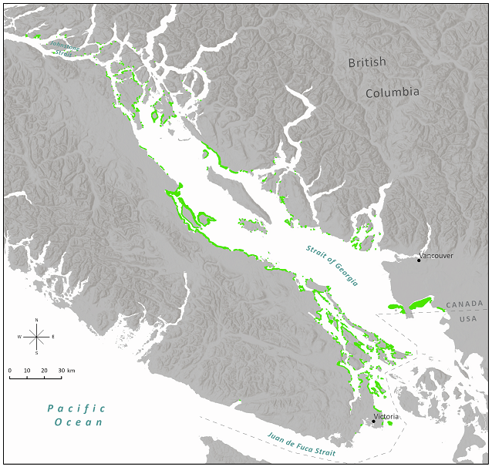

Figure 2.1: Seagrass meadows in the Strait of Georgia Bioregion and southern portions of the Northern Shelf Bioregion and Southern Shelf Bioregion. The outlines of the meadow polygons are exaggerated for visualization purposes.

## 2.2 Shoreline area adjacent to seagrass meadows

Previous guidelines on the width of marine riparian buffer zones for protecting sensitive habitat typically range from 50-150 meters (Levings and Jamieson 2001; Lemieux et al. 2004). We followed the methodology in a similar study of anthropogenic impacts (Iacarella et al. 2018) and examined shoreline modifications within 100 m of the coastline adjacent to each seagrass meadow. Quantifying modifications within a buffer zone requires generating consistent buffers from all meadows onto land. The perimeters of meadows, however, do not always exactly border the shoreline due to variable mapping accuracies and errors, as well as some meadows only existing in the subtidal zone. This would result in slightly different buffer extents on to land. Aside from a few exceptions, the majority of meadows are in close proximity to a coastline, and therefore, to create consistent width buffers on land we first adjusted the perimeter of meadows to match the coastline using digitization tools in ArcGIS.

## 2.3 Quantifying shoreline modifications

To quantify shoreline modification adjacent to seagrass, we identified any structures (e.g. buildings, houses) and areas de-vegetated from their natural state (e.g. lawns, logged areas, agriculture, armoured shoreline) within the 100 meter buffer. De-vegetated areas can increase nutrient run-off from agricultural areas and sewage outfalls, potentially resulting in eutrophication (Hauxwell et al. 2003; Vandermeulen 2005; Quiros et al. 2017). Hardened and de-vegated areas may also increase the outflow of sedimentation resulting in decreased light levels in seagrass meadows (Vandermeulen et al. 2012; Dethier et al. 2016; Todd et al. 2019).

Shoreline modifications were digitized from satellite and aerial imagery in Google Earth Pro. The most recent imagery available was used, but the dates of the imagery varied across the study area. The majority of roads were included using an existing provincial dataset (Province of British Columbia - Digital Road Atlas). This dataset consists of linear features which were buffered using the number of lanes and standard lane widths. Modifications were classified into six categories: road, residential, agriculture, industrial, greenspace, and unclear. Within each category, an additional descriptor was also listed if relevant (Table ??). Overwater structures (e.g. floathomes, docks, aquaculture) were not considered to be shoreline modifications as these are associated with a different suite of impacts (e.g. shading, boat traffic), and these features were captured in separate studies (Iacarella et al. 2019; Cristiani 2022).

To quantify the overall level of shoreline modification we totaled the area of all modification types per buffered area and calculated the percent of the buffered area that is modified. The percent modified was then associated back with the adjacent seagrass meadow.

# 3 Results

The spatial distribution of shoreline modifications varied across the region. Examples of the extent and diversity of modifications are shown in Figure 3.1, and the full dataset is accessible online (see Data availability section). As expected, the seagrass meadows with the highest total levels of adjacent shoreline modification occurred near population centers (Figure 3.2). The lowest levels of modification occurred near smaller islands and in the northern part of the study area (i.e. Johnstone Strait). The dominant modification type across the study area was residential development. Agriculture varied by latitude with most coastal agriculture occurring in the southern portion of the study area (Figure 3.3).

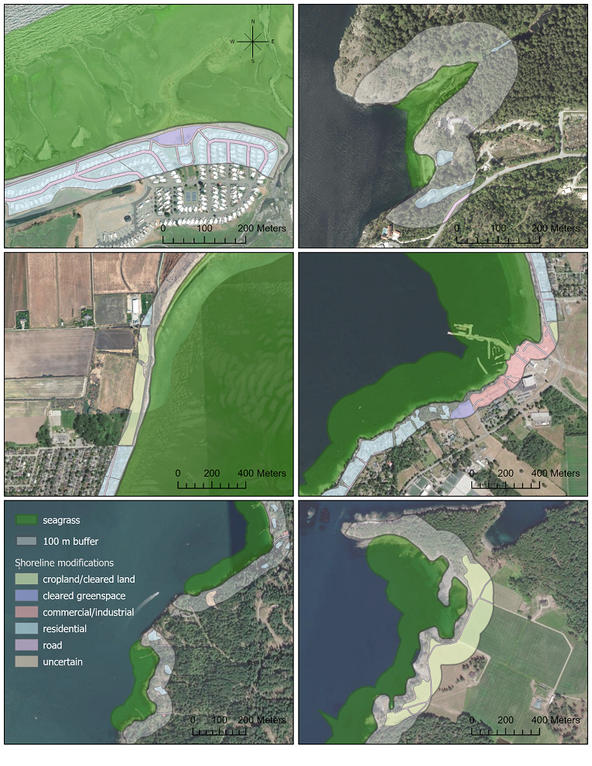

Figure 3.1: Shoreline modifications within buffered areas adjacent to seagrass meadows. All buffers are 100 meters wide, as measured from the coastline. The six selected areas are shown for example and do not imply any significance over other areas.

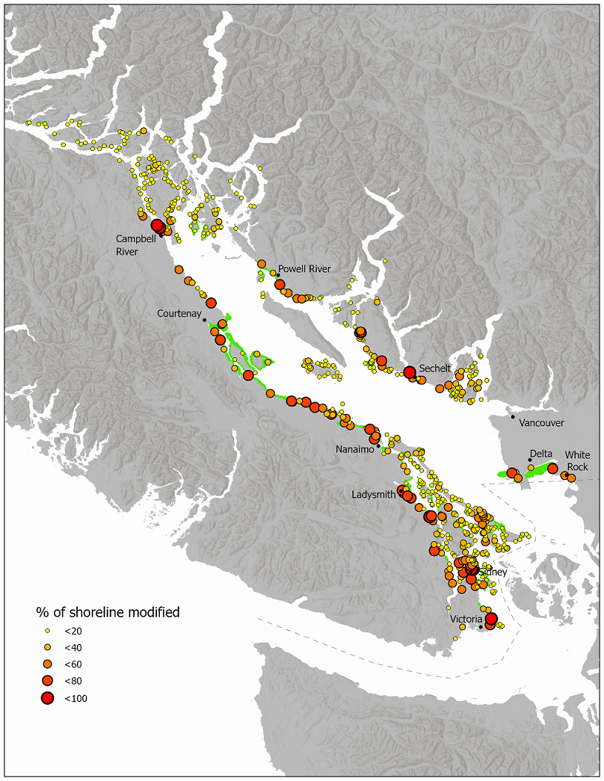

Figure 3.2: The modified percent of the shoreline buffered area adjacent to each seagrass meadow.

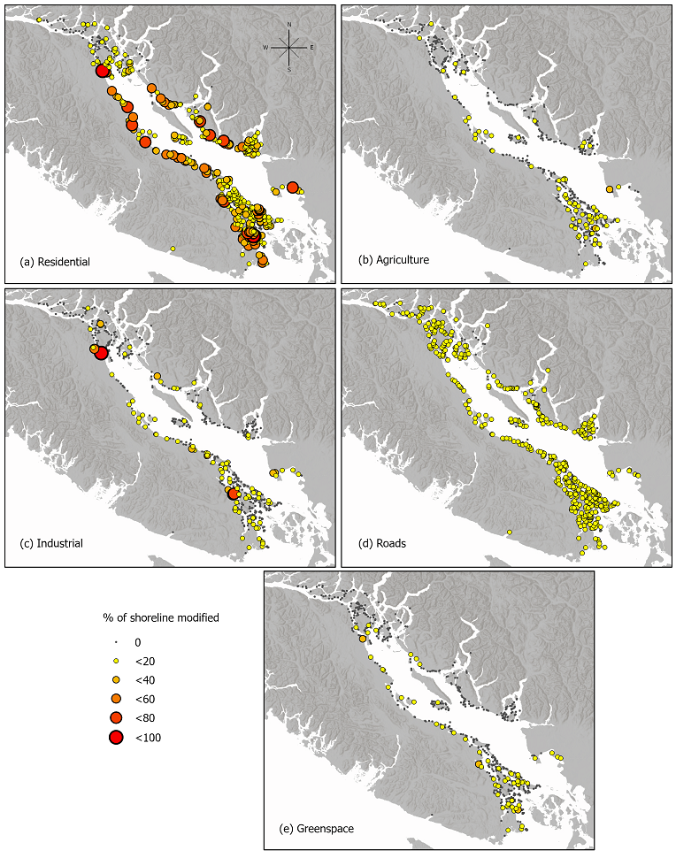

Figure 3.3: The modified percent of the shoreline buffered area adjacent to each seagrass meadow by modification type: (a) residential, (b) agriculture, (c) industrial, (d) roads, (e) greenspace.

# 4 Discussion

By quantifying shoreline modifications adjacent to seagrass meadows, we’ve provided a novel high resolution dataset for documenting land use over a large spatial extent and predicting potential impacts to nearshore ecosystems. The variation in the distribution and patterns of modifications across the region illustrate the different shoreline threats that seagrass meadows may face based on their location. While areas of high naturalness are generally targeted for conservation over degraded areas (UN CBD 2008; Rubidge et al. 2020), other criteria such as biological diversity, productivity and connectivity may result in targeting meadows that are threatened by shoreline activities (Rubidge et al. 2020; Cristiani 2022). If an area including a meadow is selected for management (e.g. an EBSA), then it’s likely the shoreline modifications will have to be considered for possible mitigation of impacts. It will then be important to know the spatial distribution of modifications because the management action will vary with the type of modification.

This analysis could be strengthened by addressing some of its assumptions and limitations. We used a uniform buffer from the coast, but there is likely a distance-decay of the impacts from certain activities, such that subtidal meadows may experience impacts differently than intertidal meadows. In addition, a narrow buffer of vegetation on the edge of the coast could be enough to mitigate the effects of a certain modifications behind this buffer. Most importantly, it will be necessary to quantify the relative severity of each modification and the vulnerability of seagrass to different pressures. For example, runoff from agricultural areas may be more damaging than runoff from residential areas (Teck et al. 2010). Shoreline modifications are representative of only one type of threat to seagrass, however, by quantifying severity and vulnerability scores, this data could be incorporated into larger cumulative effects analyses in which the overall impact of many stressors is quantified (Clarke Murray et al. 2016, 2020; Murphy et al. 2022).

Our analysis emphasizes the importance of managing seagrass and the biodiversity it supports in the spatial context of the larger seascape and landscape. While seagrass area is declining globally, it appears to be stable in the north Pacific (Dunic et al. 2021), and in the Washington state portion of the Salish Sea, seagrass has been resilient despite an increase in human activities (Shelton et al. 2016). To further enhance successful seagrass management, understanding exactly which activities may be impacting seagrass locally will likely require a more precise analysis of human activities, the stressors they generate, and the vulnerability of seagrass to these stressors. Therefore, it will be important to continue to gather the high resolution spatial data that informs the initial stage of these analyses.

# 5 Data availability

The code used to generate the dataset for this study is available at . *(perhaps consider moving just the one script to the report repo)*  
*Link to dataset wherever it gets hosted*

# 6 References

Clarke Murray, C., Agbayani, S., Alidina, H.M., and Ban, N.C. 2015. [Advancing marine cumulative effects mapping: An update in Canada’s Pacific waters](https://doi.org/10.1016/j.marpol.2015.04.003). Marine Policy 58: 71–77.

Clarke Murray, C., Hannah, L., and Locke, H. 2020. A Review of Cumulative Effects Research and Assessment in Fisheries and A Review of Cumulative Effects Research and Assessment in Fisheries and Oceans Canada. Can. Tech. Rep. Fish. Aquat. Sci. 3357: vii + 51 p.

Clarke Murray, C., Mach, M.E., and O, M. 2016. Pilot ecosystem risk assessment to assess cumulative risk to species in the Pacific North Coast Integrated Management Area (PNCIMA). Canadian Science Advisory Secretariat.

Cristiani, J. 2022. [The connectivity of coastal marine populations : Uncovering patterns of dispersal and the implications for management](https://doi.library.ubc.ca/10.14288/1.0417471). University of British Columbia.

Cristiani, J., Rubidge, E., Forbes, C., Moore-Maley, B., and O’Connor, M.I. 2021. [A Biophysical Model and Network Analysis of Invertebrate Community Dispersal Reveals Regional Patterns of Seagrass Habitat Connectivity](https://doi.org/10.3389/fmars.2021.717469). Frontiers in Marine Science 8: 1–19.

Dethier, M.N., Raymond, W.W., McBride, A.N., Toft, J.D., Cordell, J.R., Ogston, A.S., Heerhartz, S.M., and Berry, H.D. 2016. [Multiscale impacts of armoring on Salish Sea shorelines: Evidence for cumulative and threshold effects](https://doi.org/10.1016/j.ecss.2016.03.033). Estuarine, Coastal and Shelf Science 175: 106–117. Elsevier Ltd.

DFO. 2019. Design strategies for the Northern Shelf Bioregion Marine Protected Area Network. CSAS.

Dunic, J.C., Brown, C.J., Connolly, R.M., Turschwell, M.P., and Côt’e, I.M. 2021. [Long‐term declines and recovery of meadow area across the world’s seagrass bioregions](https://doi.org/10.1111/gcb.15684). Global Change Biology: gcb.15684.

Halpern, B.S., Frazier, M., Afflerbach, J., Lowndes, J.S., Micheli, F., O’NAHara, C., Scarborough, C., and Selko, K.A. 2019. [Recent pace of change in human impact on the world’s ocean](https://doi.org/10.1038/s41598-019-47201-9). Scientific Reports 9(1): 1–8.

Hauxwell, J., Cebri’an, J., and Valiela, I. 2003. [Eelgrass Zostera marina loss in temperate estuaries: Relationship to land-derived nitrogen loads and effect of light limitation imposed by algae](https://doi.org/10.3354/meps247059). Mar. Ecol. Prog. Ser. 247: 59–73.

Iacarella, J.C., Adamczyk, E., Bowen, D., Chalifour, L., Eger, A., Heath, W., Helms, S., Hessing-Lewis, M., Hunt, B.P.V., MacInnis, A., O’Connor, M.I., Robinson, C.L.K., Yakimishyn, J., and Baum, J.K. 2018. [Anthropogenic disturbance homogenizes seagrass fish communities](https://doi.org/10.1111/gcb.14090). Global Change Biology 24(5): 1904–1918.

Iacarella, J.C., Davidson, I.C., and Dunham, A. 2019. [Biotic exchange from movement of “static” maritime structures](https://doi.org/10.1007/s10530-018-1888-8). Biological Invasions 21(4): 1131–1141. Springer International Publishing.

Lemieux, J.P., Brennan, J.S., Farrell, M., Levings, C.D., and Myers, D. 2004. PROCEEDINGS OF THE DFO/PSAT SPONSORED MARINE RIPARIAN EXPERTS WORKSHOP, TSAWWASSEN, BC, FEBRUARY 17-18, 2004.

Levings, C., and Jamieson, G. 2001. Marine and estuarine riparian habitats and their role in coastal ecosystems, Pacific region. Canadian Science Advisory Secretartiat: 41.

Murphy, G.E.P., Dunic, J.C., Adamczyk, E.M., Bittick, S.J., Côt’e, I.M., Cristiani, J., Geissinger, E.A., Gregory, R.S., Lotze, H.K., O’Connor, M.I., Ara’ujo, C.A.S., Rubidge, E.M., Templeman, N.D., and Wong, M.C. 2021. [From coast to coast to coast : Ecology and management of seagrass ecosystems across Canada](https://doi.org/10.1139/facets-2020-0020). Facets 6: 1–41.

Murphy, G.E.P., Kelly, N.E., Lotze, H.K., and Wong, M.C. 2022. [Incorporating anthropogenic thresholds to improve understanding of cumulative effects on seagrass beds](https://doi.org/10.1139/facets-2021-0130). FACETS 7: 966–987.

Nagel, E.J., Murphy, G.E.P., Fast, J., Bittick, S.J., Adamczyk, M., Connor, M.I.O., Wong, M.C., and Lotze, H.K. 2020. Application of a coastal human impact metric and nitrogen loading model to 10 eelgrass ( Zostera marina ) meadows in British Columbia. Fisheries and Oceans Canada.

Nahirnick, N.K., Costa, M., Schroeder, S., and Sharma, T. 2019. [Long-Term Eelgrass Habitat Change and Associated Human Impacts on the West Coast of Canada](https://doi.org/10.2112/jcoastres-d-18-00112.1). Journal of Coastal Research 36(1): 30.

Quiros, T.E.A.L., Croll, D., Tershy, B., Fortes, M.D., and Raimondi, P. 2017. [Land use is a better predictor of tropical seagrass condition than marine protection](https://doi.org/10.1016/j.biocon.2017.03.011). Biological Conservation 209: 454–463. The Authors.

Rubidge, E., Jeffery, S., Gregr, E.J., Gale, K.S.P., and Frid, A. 2020. Assessment of nearshore features in the Northern Shelf Bioregion against criteria for determining Ecologically and Biologically Significant Areas ( EBSAs ). DFO Canadian Science Advisory Secretariat. Canadian Science Advisory Secretariat.

Shelton, A.O., Francis, T.B., Feist, B.E., Williams, G.D., Lindquist, A., and Levin, P. 2016. [Forty years of seagrass population stability and resilience in an urbanizing estuary.](https://doi.org/10.1111/1365-2745.12682) Journal of Ecology: 1–13.

Teck, S., Halpern, B., and Kappel, C. 2010. [Using expert judgement to estimate marine ecosystem vulnerability in the California Current](https://doi.org/10.1890/09-1173.1). Ecological … 20(5): 1–16.

Todd, P.A., Heery, E.C., Loke, L.H.L., Thurstan, R.H., Kotze, D.J., and Swan, C. 2019. [Towards an urban marine ecology: Characterizing the drivers, patterns and processes of marine ecosystems in coastal cities](https://doi.org/10.1111/oik.05946). Oikos: 1215–1242.

UN CBD. 2008. Decision adopted by the conference of the parties to the convention on biological diversity at its ninth meeting. UNEP/CBD/COP/DEC/IX/20.

Vandermeulen, H. 2005. Assessing Marine Habitat Sensitivity: A case study with eelgrass (Zostera marina L.) And kelps (Laminaria, Macrocystis). DFO Canadian Science Advisory Secretariat, Fisheries and Oceans Canada.

Vandermeulen, H., Surette, J., and Skinner, M.A. 2012. Responses of Eelgrass (*Zostera* *Marina* *L.*) To stress. DFO Can. Sci. Advis. Sec. Res. Doc. 2011/095: vi + 43 p.